How to Set Up and Run the Complete Recruitment Workflow in Odoo 19?
Rohan Raj | Feb 26, 2026
Recruitment is one of the most essential HR processes for any growing business. Managing job openings, tracking applicants, scheduling interviews, sending offers and converting hired candidates into employees involves multiple steps that are often handled across spreadsheets, emails and disconnected tools. In Odoo 19, the Recruitment application provides a fully integrated pipeline that manages the entire hiring process from job posting to employee creation within a single system. Every applicant is tracked through configurable Kanban stages, and the final hiring feeds directly into the Employees and Payroll applications.

Recruitment Dashboard Overview

The main Recruitment dashboard displays all job positions in a Kanban view. Each job position card shows the job title, number of new applications, total applications in progress, expected hires, job page and a button to configure the job position. Clicking on any card opens the pipeline view for that position.
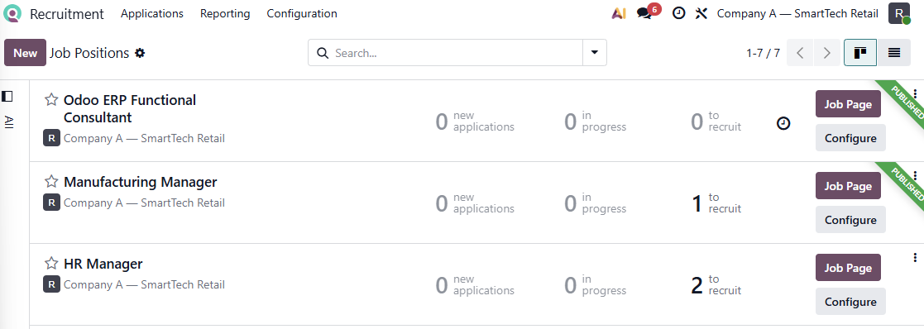

Understanding the Recruitment Pipeline in Odoo 19

The recruitment process in Odoo 19 follows a Kanban-based pipeline where each applicant moves through a series of stages from initial application to final hiring. Odoo provides six default stages out of the box.
New — The applicant has submitted an application.
Qualification — The recruiter has reviewed the application and shortlisted the candidate for further evaluation. This stage is used to separate promising candidates from those who do not meet the requirements.
First Interview — The candidate has been scheduled for or has completed the first interview round.
Second Interview — The candidate has progressed to a second interview round for further assessment.
Contract Proposal — The recruiter has prepared and sent a job offer to the candidate.
Contract Signed — The candidate has accepted the offer and signed the contract. This is the final stage and is marked as the Hired Stage in Odoo. A green HIRED banner appears on the applicant card when it reaches this stage.
These stages can be customised, renamed, reordered or extended to match the specific hiring process of any organisation. Each stage can also have an email template assigned to it, so that emails are automatically sent to applicants whenever their card moves into that stage.

Enabling the Recruitment Module

The Recruitment application is not installed by default in a new Odoo database. To install it, navigate to the Apps menu and search for Recruitment.

Apps => Search for "Recruitment" => Install

Once installed, the Recruitment application appears in the main menu. Installing the Recruitment module also installs the Employees application if it is not already present.
To enable the online job posting feature that allows publishing job positions on the company website, also install the Website application.

Configuring Recruitment Settings

After installation, review the recruitment settings to configure the available features.

Recruitment Application => Configuration => Settings

Send Interview Survey — Enable this to send questionnaires or skill assessments to applicants during the recruitment process.
Online Posting — Enable this to allow publishing job positions on the company website.
Job boards can be activated to post job positions on Monster Job Board
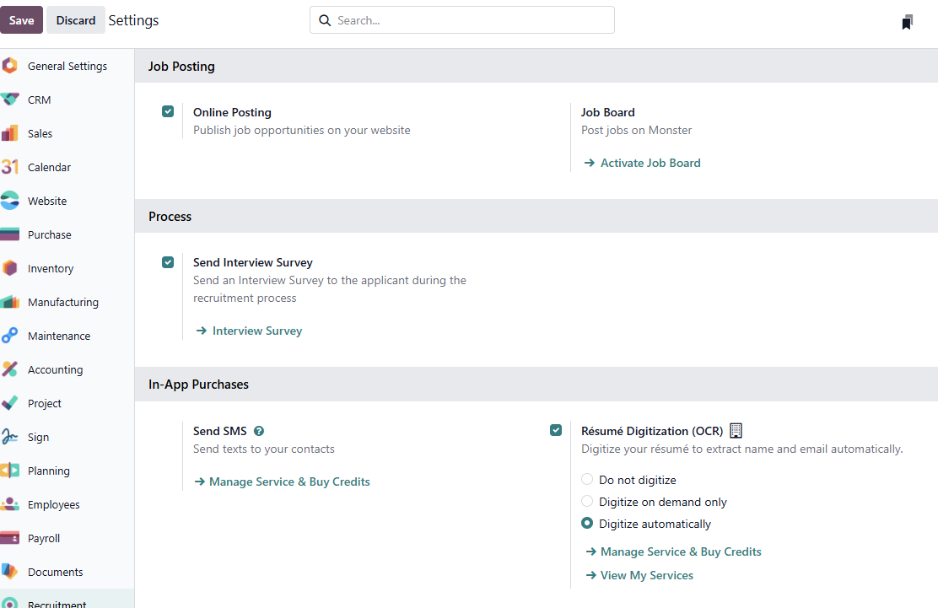
Options for SMS messaging and Resume Digitization (OCR) are available here. Resume Digitization can automatically extract the applicant's name, phone number and email from an uploaded resume using AI-powered OCR.
Click Save after making any changes.

Creating Departments

Before creating job positions, ensure that the relevant departments exist in the system. Departments help organise job positions and employees into logical groups.

Recruitment Application => Configuration => Departments => New

Create a department by entering the department name. Optionally assign a parent department for hierarchical structures and a department manager.
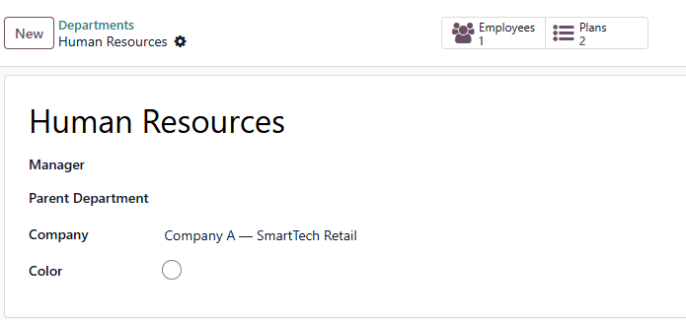

Creating a New Job Position

A job position defines the role that the company is hiring for. Each job position appears as a card on the main Recruitment dashboard and has its own pipeline of applicants.

Recruitment Application => New

Click the New button on the main dashboard. A Create a Job Position popup appears. Enter the job position name and optionally configure an application email alias. Click Create.
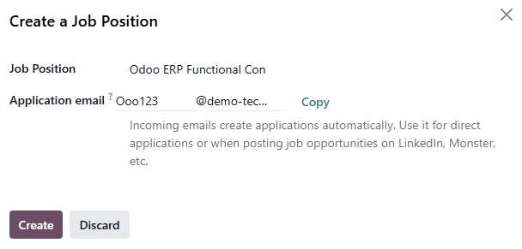

Configuring the Job Position

After creating the job position, click the configure button on the job position card to open the detailed job position form. The form has four tabs.
The Details tab contains the core configuration fields for the job position. Here we can enter the details about the job, contract type and hiring process
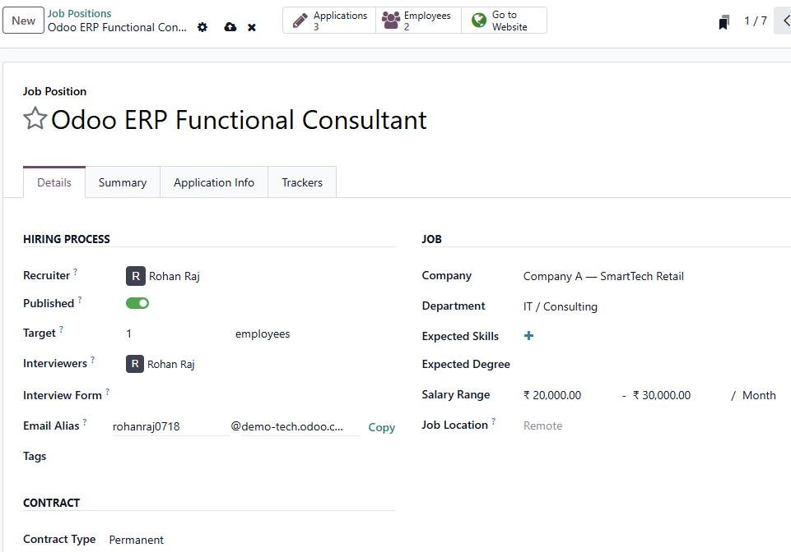
The Summary tab contains a rich text editor where the full job description can be entered. This description is visible to applicants on the website when the job is published.
The Application Info tab contains process details that inform applicants about the recruitment timeline. These details are displayed on the website job listing page.
Tracker tab is used for tracking of applications via unique URLs or email aliases linked to recruitment campaigns.

Publishing Job Positions to the Website

To attract external applicants, job positions can be published on the company website.

Recruitment Application => Configuration => Settings

Ensure that the Online Posting option is enabled.
On the main Recruitment dashboard, click the configure button on job position card and click on the Publish toggle under Details tab to publish the job position on company website.
Applicants visiting the website can view the job description, process details and application form. When they submit an application through the website form, an applicant card is automatically created in the corresponding job position pipeline.
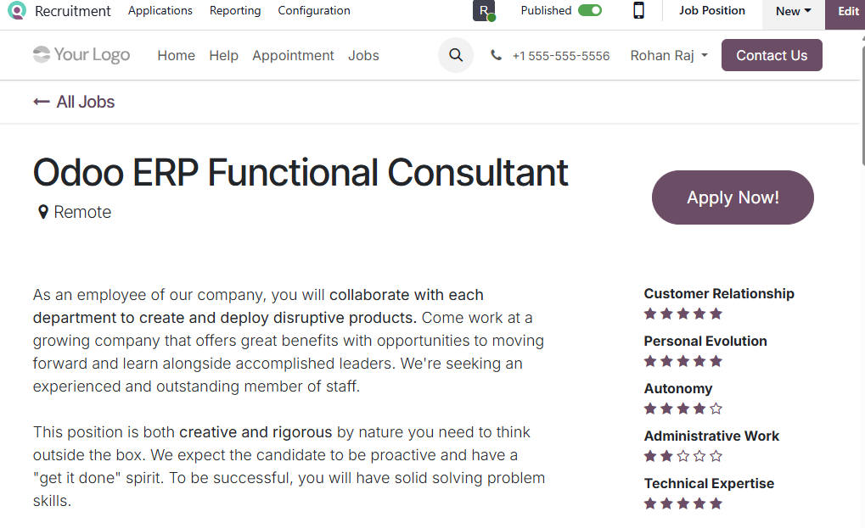

Adding Applicants

Applicants can enter the system in three ways — through the website application form when the job is published online, by sending a resume to the job position email alias, or by being manually created by the recruiter.

Recruitment Application => Select Job Position Card => New

Enter the applicant's personnel details along with the job position, recruiter and interviewers. An evaluation rating can be set using stars — one star for Good, two for Very Good and three for Excellent.
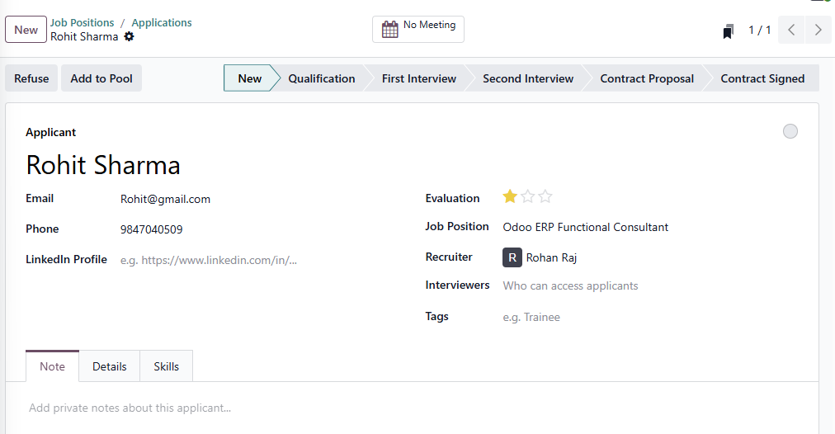
Private notes about the applicant can be added under notes tab.
In the Details Tab, enter key details of applicant such as educational qualification and expected and proposed salary
Add applicant skills under Skills tab

Walking Through the Recruitment Pipeline

With applicants created, the recruitment team moves each applicant through the pipeline stages based on their progress. Applicants can be moved between stages by dragging and dropping their cards in the Kanban view, or by clicking the desired stage on the status bar at the top of the applicant form. Each applicant card displays the candidate’s name, email address and evaluation stars. A color-coded status indicator appears on each card — grey for in progress, green for ready for next stage, yellow for waiting stage and red for blocked. The recruiter sets this status manually by clicking the small circle on the card.
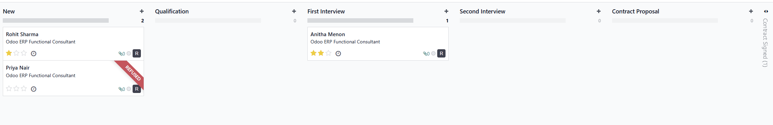

Refusing an Applicant

At any point during the recruitment process, a candidate can be refused. Odoo provides a structured refusal process with predefined reasons.
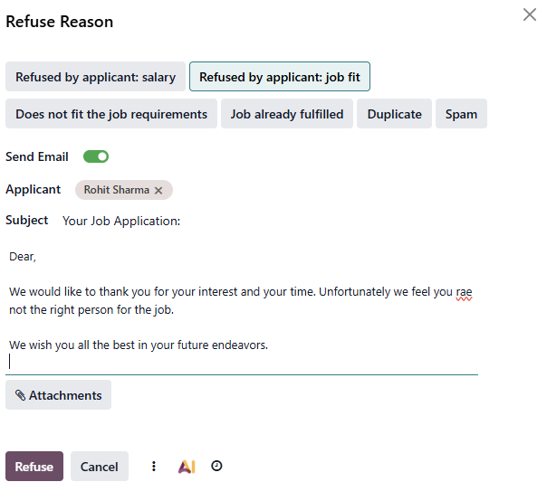
Open the applicant card and click the Refuse button. A popup appears asking the recruiter to select a refuse reason. An email can optionally be sent to the applicant informing them of the decision.

Creating an Employee from a Hired Applicant

Once an applicant is hired and their contract is signed, the final step is to create their employee record in the system.

Open the Hired Applicant Card => Click Create Employee

Clicking this button opens a new employee form prepopulated with the applicant's name, department, job position and job title. The recruiter completes the remaining employee details such as work address, work email, coach and other personal information, then saves the record.
After the employee is created, the applicant card displays a link to the employee record through a smart button, providing a direct connection between the recruitment history and the employee record.
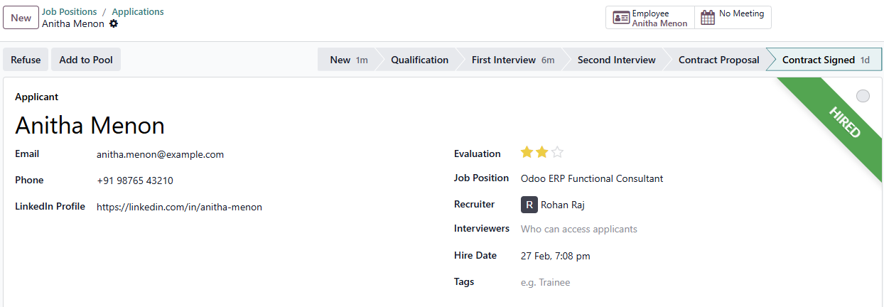

Conclusion

Hiring the right people is hard enough — the last thing any company needs is paperwork slowing things down. Odoo 19 Recruitment keeps everything in one place, so recruiters spend less time chasing emails and updating spreadsheets, and more time actually finding great candidates. From job creation to hiring and employee record creation, the complete recruitment lifecycle is managed in one unified system.

